**When Anticompetitive Concerns Take a Backseat: Assessing First Air & Canadian North Merger through Granger Causality Test**

Adelina Nie

Economics of Antitrust

**Abstract.** *Canadian North* and *First Air* has been two critical regional airlines to northern Canada for goods supply and connecting to larger cities in the south. In 2019, the Government of Canada approved a proposed merger between these two airlines for *public interest* considerations despite potential anticompetitive concerns. To evaluate this merger and the proclaimed *public interest*s, I collect air movement data and GDP per capita of two northern regions, Nunavut and Northwest Territories (NWT), over the past two decades and conducted a Granger Causality analysis between these two variables. The result shows a unidirectional causality from air transport to GDP per capita in NWT, suggesting that enhancements in airline service due to the merger could indeed lead to long-term economic benefits. Conversely, this causality runs in the opposite direction in Nunavut which may not experience direct economic benefits from the merger. However, the region can still be advantaged from improved airline qualities given the largely limited road network. Further assessment on this merger should incorporate exogenous factors and more specific air transport data related to the involved airlines.

**1. Introduction**

Characterized by the extreme climate conditions and a remarkably sparse population, the three northern territories of Canada, Yukon, Nunavut, and Northwest Territories (NWT) cover 40% of the country’s landmass yet only nurture less than 1% of the total population.[1] The vast land mass endows the regions with plentiful natural resources, making the resource mining industry one of the primary economic drivers of the North[2]. Traditional economic activities such as hunting, fishing, and art crafts are also significant economic activities of the Northern economy (especially in Nunavut[3]) due to the large proportion of Indigenous people, which comprises 85.8% of the population in Nunavut, 49.6% in the NWT and 22.3% in Yukon [(Statistics Canada, 2021)](https://www150.statcan.gc.ca/n1/daily-quotidien/220921/dq220921a-eng.htm?indid=32990-1&indgeo=0)[4]. While the median after-tax household income of Northern Canada often outperforms that of quite a few other southern provinces[5], the income for the Indigenous population has always been unevenly allocated. Indigenous people in Canada generally have been experiencing long-lasting low socio-economic status stemming from the long history of colonialism and discrimination[6]. The poverty, along with the challenges to access nutritious and perishable food in the North places Indigenous people of Arctic communities at a much higher risk of food insecurity (i.e., not having sufficient food to meet basic needs) compared to other provinces. *Statistics Canada* reported in 2021 that the percentage of households with food insecurity in Nunavut and NWT were 46.1% and 22.2% respectively, significantly higher than the overall 17.8% of food insecurity across the other 10 provinces of southern Canada[7].

The development of Northern Canada has heavily relied on airline services for two primary reasons. Many remote communities, especially Nunavut, are located on islands surrounded by frozen oceans, which hinders the establishment of traditional road networks. Thus, airline service is essential for connecting northern communities with each other as well as with larger cities like Calgary and Toronto in the south. More importantly, the harsh climate conditions and underdeveloped infrastructures bring challenges for local people to completely self-sustain, which necessitates air shipments of perishable food and other commercial products from the south.[8] The airline *Canadian North* has been serving Arctic communities since founded in 1989, providing scheduled flights to 16 remote regions in Nunavut and NWT. *First Air*, another airline which used to operate services for 32 communities in Nunavut and NWT, was once a major competitor of *Canadian North* with their overlapping flight routines. In 2018, the parent companies of First Air and Canadian North announced the decision to merge these two airlines into one entity, due to the highly inefficient operations from the two airlines’ overlapping flight schedules where the total supply far exceeded the demand. The two parties anticipated the benefits from this merger, such as financial stability and improved safety of the aircrafts, thereby better serving and bolstering the economic development of Northern communities. The proposal was nonetheless advised against by the Competition Bureau of Canada because of anti-competitive concerns. For one reason, the merger would have eliminated the competition between First Air and Canadian North which used to spur consumer benefits, such as ticket sales and baggage allowances. It is also noteworthy that the airline market in Northern Canada is quite distinct from other parts of the country. Airlines operating in the North face more challenges such as the harsh climate and geographical conditions, which elevate operational costs and limit the air travel demand because of the small population density in the North. As these challenges create a high barrier of entry to the airline industry in Canada’s north, the merged entity would potentially become the only air service in the relevant airline market. The Competition Bureau therefore labeled this transaction as a *“merger to monopoly”*, expressing concerns that the merger could substantially lessen the air service competition in quite a few regions of the North. This could lead to higher flight prices, fewer flights, and lower passenger and cargo capacities.[9]

Despite the Competition Bureau’s concerns on anticompetition, the Government of Canada still approved the proposed merger between First Air and Canadian North, citing broader *public interest* considerations[10]*.* Although specific *public interests* were not specified by the Government; it is reasonable to infer that they pertain to the economic development of the Northern communities. For the research objective of this paper, I intend to define indicators for public interests and evaluate whether the government’s decision to approve this *merger to monopoly* has been indeed leading to improvements in the defined metrics. This analysis will involve exploring the causal relationship between air services and economic activity in NWT and Nunavut.

**2. Literature Review**

To investigate what “public interest” issues considered by the Canadian Government in approving the proposed merger, and whether the merger between First Air and Canadian North contributes to these public interests, it is crucial to understand the interaction between air transport and the economic development of Northern Canada. [Zhang & Graham](https://doi.org/10.1080/01441647.2020.1738587) (2020)[11] summarized the airline-economy interaction mechanism with three main linkages. The first one is the supply-chain effect led by operations of aviation industry, including employment and input spending. The airline operations subsequently generate air travel supply by providing scheduled flights to the public, thereby facilitating a spillover effect which boosts economic growth by promoting trading, tourism, and productivity. The last linkage, the feedback effect, is a reverse linkage of the spillover effect. The economic development of a region generates more capital investments and increases in air travel demands, therefore stimulating the growth of the aviation industry. These three linkages demonstrate that there exists a bi-directional causality between regional economy and air transport, which should be examined to further explore how this airline merger made an impact in the Northern regions of Canada.

While numerous studies investigated the causal linkage between air transportation and economic growth, there is no unanimous conclusion on the direction of this causality to be drawn from the previous research findings. [Hakim and Merket (2016)](https://doi.org/10.1016/j.jtrangeo.2016.09.006)[12] examined this reciprocal relationship in eight South Asian countries characterized by low income and large populations, confirming a unidirectional causality running from GDP growth to air activity, with no significant spillover effects led by the aviation sector. Similarly, this simultaneity was also studied for six sub-Saharan African countries ([Tolcha et al., 2020](https://doi.org/10.1016/j.jtrangeo.2020.102771))[13], with a similar conclusion that the causality primarily runs from economic development to air transport in most of the countries, although there is a witnessed spillover effect as a result of the air transport growth in Ethiopia, due to the relative advantage of its geographical location and biggest airline group among the six countries. This bidirectional causality analysis is also conducted in the context of BRICS countries where only spillover effect is detected ([Ali et al., 2023](https://doi.org/10.1016/j.jairtraman.2022.102335))[14], and in Mexico where the causality runs in both directions, emphasizing mutual influence between air transport demands and economic growth ([Brida et al., 2016](https://doi.org/10.1504/WRITR.2016.078136))[15].

The literatures mentioned above examined the aviation-economy interaction on the national level. For the research objective of this paper which only focuses on Nunavut and Northwest Territories, two remote regions in Northern Canada, the Australian study by [Baker et al.](http://dx.doi.org/10.1016/j.jtrangeo.2015.02.001) (2015)[16] is particularly worth highlighting. Using annual air passenger movements as a proxy for airport activity and real aggregate taxable income as an economic indicator, the authors analyzed panel data of 88 regional and remote airports in Australia and found a significant bidirectional Granger causality - both regional airports and local economy make direct impacts on each other. [Pot & Koster (2021)](https://doi.org/10.1016/j.jtrangeo.2021.103262)[17] adopted a similar framework, the Granger causality test with panel data, on various regions in Europe which are categorized into three groups – peripheral regions, middle regions, and core regions for heterogeneity. The results also suggest bidirectional effects between air activity and economic development in remote regions, whereas in the core regions only the feedback effect holds true.

**3. Data & Methodology**

**3.1 Data**

This empirical causal analysis is conducted using indicators of air transport and economic activities for NWT (1997-2023) and Nunavut (1999-2023) respectively. Air transport is measured by the number aircraft movements (*AIRM*) at 4 major airports (Yellowknife and Inuvik airport of NWT; Iqaluit and Rankin-Inlet airport of Nunavut) covered by both First Air and Canadian North, which indicates the total number of arrivals and departures of aircrafts into and out of an airport. GDP per capita (*GDPPC*) is used as the economic indicator, measured in chained dollars with 2017 as the base year. Chained-dollar GDP adjusts the effects of inflation, which is equivalent to real GDP, thus GDP deflating is unnecessary in this case. Both GDP per capita and aircraft movements are scaled by taking logs, which is interpreted as percentage changes in a regression setting. All the data are obtained from *Statistics Canada* website[18]*.*

**3.2 Granger causality framework**

***3.2.1 Standard VAR model***

The airline-economy causality analysis in this paper follows a three-step Granger causality test, of which the foundation is that only the past values, but not the future values of a given variable *X* can impact the present values of the other variable *Y[19]*. For two stationary time-series variables (i.e., the statistical properties remain the same over time) *X* and *Y*, variable *X* is said to Granger-cause variable *Y* if the *Y* is better forecasted by the past values of both *X* and *Y* rather than its own past values only. The standard Granger test employs a Vector Autoregression (VAR) model which captures the mutual relationship among multiple variables. The VAR model for variables *X* and *Y* consists of the *Autoregressive Distributed Lag* (ADL) models with lags *p* of the two variables respectively:

$Y_{t}= α_{1}+δ_{11}Y_{t-1}+…+δ_{1p}Y_{t-p}+β_{11}X_{t-1}+…+{β_{1p}X}_{t-p}+ϵ_{1t}$ (1)

$X_{t}= α_{2}+δ_{21}X_{t-1}+…+δ_{2p}X_{t-p}+β_{21}Y_{t-1}+…+{β_{2p}Y}_{t-p}+ϵ_{2t}$ (2)

Equation (1) and (2) test whether *X* Granger causes *Y* and vice versa. If no lagged values of *X* (or *Y*) are significant in equation for Y (or *X*), then it indicates that *X* (or *Y*) does not Granger-cause *Y* (or *X*). A more rigorous approach is to test the joint significance of all the lagged terms of X (or Y) under the hypothesis $H_{0}:β_{i1}=β_{i2}=…=β_{ip}=0$ against alternative hypothesis that at least one of the coefficients is non-zero. In other words, the key is to compare whether the restricted model under *H0* or the unrestricted model under *H1* performs better. The test statistics can be computed by F test or Wald test which follows a chi-square distribution.

***3.2.2 Unit root test***

The Granger causality test with VAR model shown above requires that the time series data X and Y are both stationary, which makes the stationary test, or more commonly called a unit root test usually the first step of a causality analysis. Stationarity is critical since the causal test results are sensitive to the stationary status of the data, and different approaches should be adopted to deal with stationary and non-stationary data[20]. The Augmented Dickey Fuller (ADF) unit root test[21] will be conducted which follows the equation

$∆y_{t}= α+βt+γy_{t-1}+\sum_{i=1}^{p}{δ_{t}∆y_{t-i}}+ε_{t}$ (3)

where $α$ + $βt$ is the deterministic component which can be either included or not, and the lagged difference terms $\sum_{i=1}^{p-1}{δ_{t}∆y_{t-i}}$ are used to approximate the autoregressive process. The number of lags *p* is usually selected based on information criteria such as AIC and BIC. ADF unit root test examines the null hypothesis $γ=0$ for non-stationarity (unit root exists) against alternative hypothesis for stationarity (no unit root existing). Three kinds of test regressions are identified based on the characteristics of time series data:

1. Only constant $α$ is included when the data series is non-trending and expected to have a non-zero mean under the alternative (e.g., interest rates). The test regression is thus expressed as

$∆y_{t}= α+γy_{t-1}+\sum_{i=1}^{p-1}{δ_{t}∆y_{t-i}}+ε_{t}$ (4).

1. The whole deterministic time trend component $α+βt$ is included, usually for variables with trends over time (e.g., asset price, real GDP). The test regression under this case is the same as equation (3).
2. The deterministic component is completely excluded when the non-trending variables have an expectation of 0. The test regression thus becomes

$∆y_{t}= γy_{t-1}+\sum_{i=1}^{p-1}{δ_{t}∆y_{t-i}}+ε_{t}$ (5).

***3.2.3 Cointegration & VECM***

While most of the macroeconomic data are non-stationary in nature, it has also been demonstrated that the linear combination of two non-stationary series with the same order of integration (i.e., the number of differences needed to make the data stationary) can be stationary (Enger & Granger, 1987)[22], under which case the two variables are said to be *cointegrated*. To examine whether cointegration exists between two variables, the *Engle-Granger* method is implemented by conducting ADF unit root test explained in the previous section on the residuals of OLS regression $y_{t}= α+βx_{t}+μ_{t}$. Cointegration is indicated when the residuals are stationary, suggesting a long-run causal relationship existing between two variables. VAR model is no longer appropriate to use under cointegration since it can spuriously detect the short-run association by differencing and fails to capture this long-run equilibrium. The Vector Error Correction Model (VECM) is therefore specifically designed for cointegrated time series data. Consider equation (1) and (2) again, suppose the long-term relationship between *X* and *Y* is modeled as a linear regression $Y_{t}=b+kX_{t}+ε_{t}$, the Error Correction Term (ECT) at time *t* is defined as the residual of this regression $ε_{t }{=Y}_{t}-b-kX_{t}$, which evaluates and corrects the disequilibrium from the past. The VECM model captures both short-run dynamics and long-run equilibrium by the form

${∆y}_{t}=α_{1}+\sum_{j=1}^{q}{{β_{1q}∆y}_{t-j }}+\sum_{j=1}^{q}{δ_{1q}{∆x}_{t-j }}+φ_{1}{ECT}_{t-1}+ϵ_{1t}$ (6)

${∆x}_{t}=α_{2}+\sum_{j=1}^{q}{{β_{2q}∆x}_{t-j}}+\sum_{j=1}^{q}{{δ_{2q}∆y}_{t-j }}+φ_{2}{ECT}_{t-1}+ϵ_{2t}$ (7).

The coefficient of ECT indicates the rate of deviation adjustment from the equilibrium and is usually between negative one and zero, interpreted as the percentage of deviations being corrected. To examine the short-run and overall causality, Wald test will be implemented to test the following hypothesis:

$H_{0}: δ_{ij}=0 ∀ j$, indicating no short run causality;

$H_{0}: {ϵ_{i}=0 \& δ}_{ij}=0 ∀ j$, indicating no overall causality.

One last note, if two variables are neither stationary nor cointegrated, then the standard Granger causality test should still be adopted, with an extra step to transform the non-stationary data into stationary ones by taking differences. To summarize, this three-step Granger causality test follows the steps below:

1. Conduct the ADF unit root test on each of the variables to test stationarity.
2. Examine whether the involved two endogenous variables are cointegrated.
3. If two variables are cointegrated, adopt VECM to investigate the causal direction.
4. If two variables are neither stationary and nor cointegrated, transform them into stationary ones by taking differences before using standard VAR model.

**4. Empirical Results & Discussion**

Figure 1 in the appendix presents the time trends of AIRM plotted with GDPPC (both logged) for each airport. Notably, all airports experienced a drastic decline in the number of AIRM from 2019 to 2020, potentially attributed to the impacts of COVID-19, followed by a post-2020 rebound. This pattern is particularly salient for Yellowknife and Iqaluit airport, the largest airports of NWT and Nunavut, respectively. It is also noteworthy that while the GDPPC of NWT has been fluctuating throughout the selected period, Nunavut’s GDPPC exhibits a consistent upward trend. Table 1 provides the correlation coefficients between the two variables. Apart from the Rankin-inlet airport in Nunavut whose AIRM is negatively correlated (-0.2423) to GDPPC of the region, a positive association between AIRM and GDPPC is demonstrated for all other three airports (0.3712 for Yellowknife; 0.3567 for Inuvik; 0.1265 for Iqaluit).

**4.1 Unit root test results**

The ADF unit root test is firstly conducted for all variables based on the description in section 3.2.3. Equation (3), incorporating the complete deterministic component, is applied to GDPPC for both regions, given the clear time trends depicted in Figure 1. Equation (4) with a constant only is examined for AIRM (recall that both GDPPC and AIRM are logged). Table 2 provides the test statistics under null hypothesis, the number of lags (the value of *p*) chosen by AIC, the corresponding critical values at 5% significance level, and the order of integration (i.e., the number of differences needed to make the data stationary) for each variable. The null hypothesis is rejected if the test statistic is smaller than the critical value. The result confirms that all variables under consideration are all non-stationary (null not rejected).

**4.2 Cointegration Test Result**

Given the non-stationarity and a consistent order of integration *I(1)* for all variables of interest indicated by the unit root test results, the causality analysis proceeds to explore cointegration. As explained in section 3.2.3 that cointegration is assessed by examining the stationarity of residuals derived from the linear regression of two variables (in this case, GDPPC and AIRM). However, owing to the simultaneity between airline activity and economy, the residuals can be obtained from both of the following regressions:

$$log⁡({GDPPC}_{t})= α+β*\log\left({AIRM}_{t}\right)+ε_{1t}$$

$log⁡({AIRM}_{t})= α+β*\log\left({GDPPC}_{t}\right)+ε_{2t}$.

Thus, residuals from both regressions, $ε_{1t}$ and $ε_{2t}$, are evaluated for separately stationarity according to equation (5). It is expected that residuals possess a mean value of zero and exhibits no trend over time (autocorrelation) under alternative hypothesis of non-stationarity. From Table 3, it is interesting to observe that while both statistics of Yellowknife airport reject the null hypothesis, indicating the existence of cointegration, the other three airports nonetheless present conflicting test statistics for $ε_{1t}$ and $ε_{2t}$. However, given that at least one statistic rejects the null which suggests cointegration, a VECM which follows equation (6) and (7) is implemented for further investigation. Note that in this case the variables are measured in first-differenced log value, representing the growth rate. For convenience, the ADL model with GDPPC as the explanatory variable will be labelled as AIRM-GDPPC, meaning that the causality runs from AIRM to GDPPC, and GDPPC-AIRM vice versa.

**4.3 Granger causality results**

Model 1-8 in appendix present the VECM summaries of all models. Considering the limited sample size and risk of overfitting, a lag number of two is selected for Yellowknife, Inuvik, and Iqaluit airport guided by few different information criteria (AIC; HQ; SC; FPE), whereas Rankin-Inlet airport keeps only one lag. The F statistics and the corresponding p-values highlight the significant overall explanatory power at 10% level in only three models: AIRM-GDPPC of Yellowknife airport (Model 1), AIRM-GDPPC of Inuvik airport (Model 3), and GDPPC-AIRM of Rankin-Inlet airport (Model 8). According to adjusted R2, these models explain 22.15%, 34.84%, and 23.14% of the variances in data, respectively, meanwhile sharing a common pattern where **only** the error correction term displays a significant coefficient which illustrates a long-run causality. To interpret the coefficients of error correction terms, taking Yellowknife airport as an example, with a long-term equilibrium presenting in the relationship between the growth of AIRM and GDPPC, the coefficient informs that 44.36 percents of the deviations from this equilibrium will be corrected within a year. Meanwhile, several negative coefficients are observed for lagged terms, indicating adverse effects from past growth of AIRM (or GDPPC) on the current growth of GDPPC (or AIRM). Nevertheless, the insignificance of these coefficients on the lagged terms implies negligible impacts on the dependent variable. For the remaining models, the adjusted R2 values hovering close to zero indicate underfit and potential model specification problems, and there is no individual coefficients attaining significance. Hence, it can be concluded that a long-run relationship does exist in NWT, running from the growth of AIRM numbers to GDPPC for both Yellowknife and Inuvik airports, while the reverse causality direction holds true in Nunavut and solely pertains to Rankin-Inlet airport. For such a long-term equilibrium, any deviations from the equilibrium status will be eventually corrected and revert to equilibrium. The insignificant lagged terms underscore the absence of short-run causality, suggesting that any changes of growth from the past one or two years will not affect the growth rate of the current year.

To further corroborate the presence of both long-run and short-run Granger causality between the two variables, Table 4 displays the Chi-squared statistics of the Wald test for short-run causality and stronger Granger causality described in section 3.2.3. Test statistics rejecting the null hypothesis of no causality are highlighted in red, perfectly aligning with the findings from the VECM summary above. This evidence consolidates that in NWT, the growth in the number of AIRM only Granger causes GDPPC growth in the long run, with short term dynamics remaining unimpactful. Conversely, in Nunavut, the growth of GDPPC tends to drive the growth of AIRM at Rankin-Inlet airport only in the long term as well.

**4.4 Discussion**

Section 4.3 uncovers an interesting empirical finding regarding the divergent direction of economy-aviation causality in NWT and Nunavut, which can be possibly explained by the following reasons. Figure 2 illustrates that NWT had been consistently outpacing Nunavut in per capita GDP until 2020 when this gap began to shrink. However, there is a steady increase in the per capita GDP of Nunavut over the past two decades, contrasting with the more stable trend observed in NWT, which signals a developmental stage of Nunavut’s economy. In such a situation, it is reasonable that GDP per capita tends to be the driving force in the airline-economy causal relationship due its constant growth. Remarkably, this pattern resonates with the conclusion Zhang & Graham (2020)[23] reached in their review paper, which claims that a unidirectional causality from air transport to the economic growth is usually recognized in more developed economies, while the reverse and reciprocal relationship tends to prevail in less developed ones. Analogously, NWT can be viewed as the *more developed* economy whereas Nunavut represents the *less developed* one based on their per capita GDP. In addition, the structure of economic activities may also influence the direction of causality. While both regions heavily rely on natural resources mining as the main industry, Nunavut’s economy also encompasses traditional practices such as fishing, hunting, and crafting, which may depend more on the local resources and environmental conditions than air transport. Consequently, GDP growth in Nunavut may be less responsive to the growth of air transport, but instead stimulate larger air travel demand.

Returning to the anticompetitive merger between First Air and Canadian North, the findings of this empirical causality analysis suggest that the growth in the number of aircraft movements only leads to a rise in GDP per capita in NWT, indicating a spillover effect. Note that Yellowknife and Inuvik airports are the only two NWT airports covered by both airlines, thus from the perspective of GDP per capita in this region, the Canadian Government’s advocacy for public interest considerations should remain valid if the merger in fact results in more efficient air services. Furthermore, the absence of short-term causality also assures that potential temporary reductions in flight numbers due to the merger will not make any significant impacts on the growth of GDP per capita, although other inconveniences may arise for the public. In the case of Nunavut where the causality operates in the opposite direction, the merger may not directly contribute to per capita GDP growth. However, improved airline qualities resulting from the merger can still benefit the public, especially given the region’s complete reliance on air traffic due to the restriction of road networks.

**5. Conclusion**

The contentious merger between First Air and Canadian North shows a scenario when the Government attempts to balance anticompetitive concerns over broader public interest issues. To evaluate whether the Government’s approval of this merger truly serves the *public interests*, a Granger causality test is implemented to investigate whether air transport contributes to the economic development in Northwest Territories and Nunavut, the regions served by the two airlines. For Northwest Territories, the findings reveal that an increase in the growth rate of flight movements indeed leads to a long-term growth rate of per capita GDP, while the short-term fluctuations is unlikely to make any significant impacts. Given this evidence, the Government’s prioritization for public interests over anticompetitive concerns may be justified, if the merged airline commits to enhance airline services over the long term. However, the benefits in terms of per capita GDP growth may not be observable in the years immediately following the merger due to absence of short-run effects. Nunavut, despite not experiencing benefits from an economic perspective, may still take advantages from the merger due to its heavy dependence on air transport. Thus, to conclude, the Canadian Government’s decision to approve First Air and Canadian North merger appears to be appropriate.

Caution also needs to be exercised when interpreting this empirical analysis, as omitted variable biases can still lead to spurious relationship given that no other exogenous variables are taken into account. On top of that, the aircraft movements may not be the most precise indicator of air traffic, since it only tracks the movements of flights rather than the actual number of passengers or scheduled flights. Moreover, the inclusion of all airlines departing from or arriving at the involved airports in the measurement of aircraft movements does not directly represent Canadian North and First Air at all. Finally, it is necessary to keep in mind that the models primary capture very small changes (i.e., rate of growth), which could explain the lack of significance in short-term effect. However, this does not necessarily discount the possibility that larger-scale changes can have meaningful short-term impacts, as supported by numerous existing studies. To facilitate a thorough assessment on the impact of this merger, further research should focus on specific air traffic data of First Air and Canadian North while also exploring potential exogenous factors.

**Appendix**

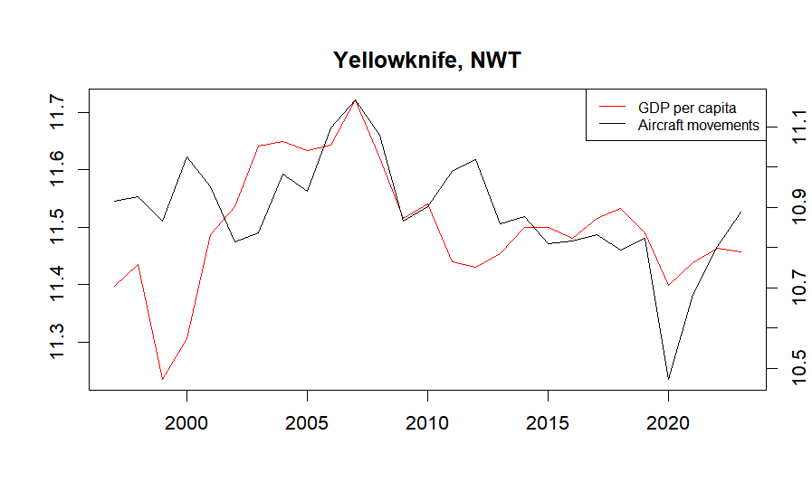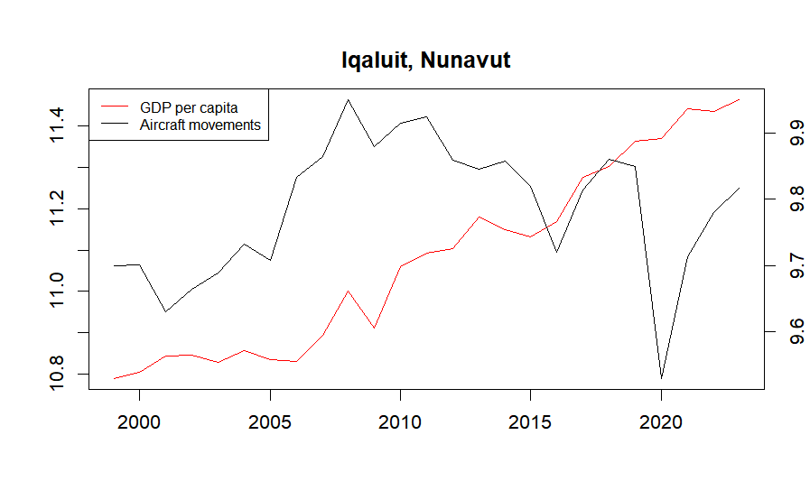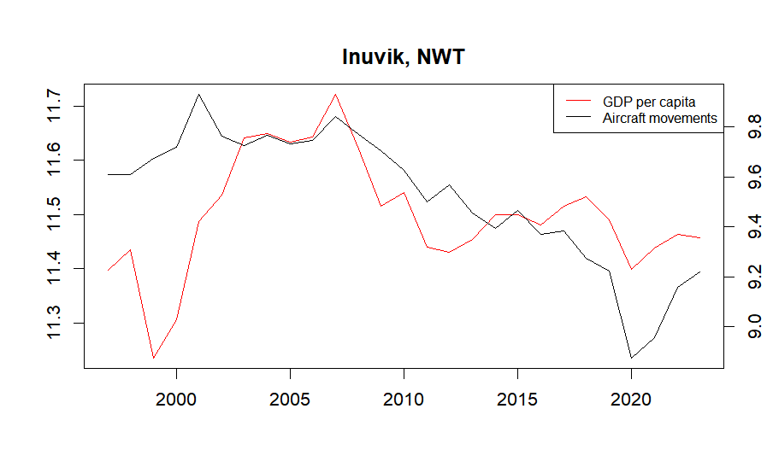Figure 1. GDP per capita (log) & Aircraft movements

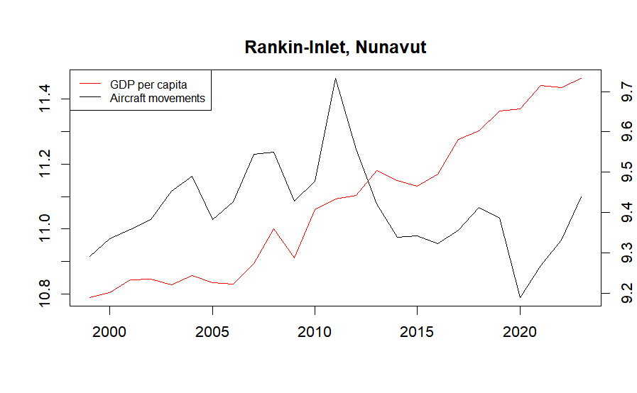Figure 2. GDP Per capita

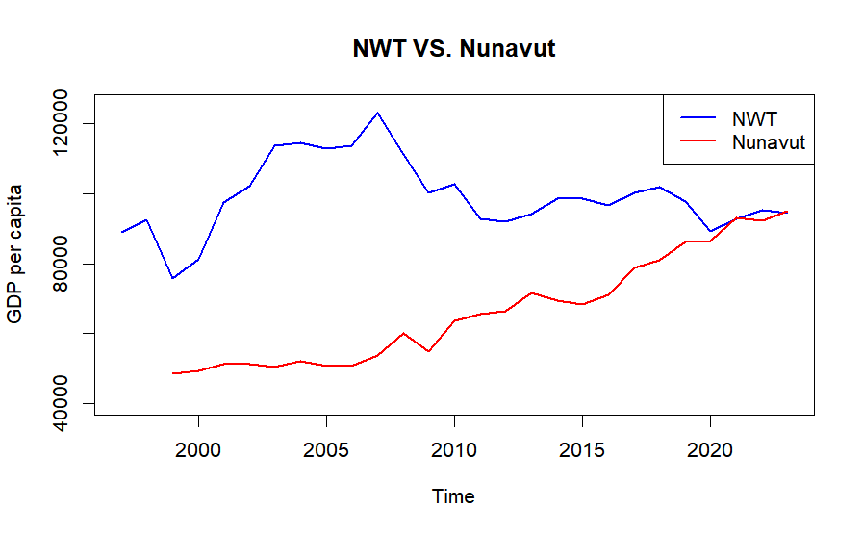

|  |  |  |  |
| --- | --- | --- | --- |
| Table 1. Correlation Summary | | | |
| Pair of variable | Region | Airport | Correlation |
| GDPPC & AIRM | NWT | Yellowknife | 0.3719986 |
| Inuvik | 0.3566523 |
| Nunavut | Iqaluit | 0.1265182 |
| Rankin-Inlet | -0.2423237 |

|  |  |  |  |  |  |
| --- | --- | --- | --- | --- | --- |
| Table 2. Unit Root Test | | | | | |
| Region | Variables | Number of lags | t statistic | Critical value (5%) | Order of integration |
| NWT | GDP per capita (log) | 1 | -2.0713 | -3.5 | 1 |
| Yellowknife Aircrafts movement (log) | 1 | -2.2449 | -2.93 | 1 |
| Inuvik Aircrafts movement (log) | 1 | -0.7641 | -2.93 | 1 |
| Nunavut | GDP per capita (log) | 1 | -2.35 | -3.6 | 1 |
| Iqaluit Aircrafts movement (log) | 1 | -2.1093 | -3 | 1 |
| Rankin-Inlet Aircrafts movement (log) | 1 | -2.7426 | -3 | 1 |

|  |  |  |  |  |
| --- | --- | --- | --- | --- |
| Table 3. Engle-Granger Cointegration Test | | | | |
| Region | Airport | t statistic - $ε_{1}$ | t statistic - $ε_{2}$ | Critical value (5%) |
| NWT | Yellowknife | -2.4089 | -2.5844 | -1.95 |
| Inuvik | -2.195 | -0.977 | -1.95 |
| Nunavut | Iqaluit | -0.0664 | -2.1252 | -1.95 |
| Rankin-Inlet | -0.6204 | -3.1387 | -1.95 |

|  |  |  |  |  |  |
| --- | --- | --- | --- | --- | --- |
| Table 4. Wald Test for Short-run Granger Causality and Overall Granger Causality | | | | | |
| Airport | Model Direction | SR Wald statistics | SR p-value | Overal Wald statistics | Overall p-value |
| Yellowknife | AIRM-GDPPC | 1.3225 | 0.5162 | 9.8459 | 0.01992 |
| GDPPC-AIRM | 0.9593 | 0.619 | 3.7664 | 0.2878 |
| Inuvik | AIRM-GDPPC | 1.7217 | 0.4288 | 15.268 | 0.001601 |
| GDPPC-AIRM | 1.2427 | 0.5372 | 1.2576 | 0.7392 |
| Iqaluit | AIRM-GDPPC | 2.1777 | 0.3366 | 2.6482 | 0.4491 |
| GDPPC-AIRM | 0.059 | 0.9709 | 3.3042 | 0.3471 |
| Rankin-Inlet | AIRM-GDPPC | 0.55 | 0.7596 | 0.2138 | 0.8986 |
| GDPPC-AIRM | 1.3588 | 0.507 | 9.6221 | 0.008139 |

|  |  |  |  |  |  |  |  |  |  |
| --- | --- | --- | --- | --- | --- | --- | --- | --- | --- |
|  | Model 1: AIRM-GDPPC (Yellowknife) | | | |  | Model 2: GDPPC-AIRM (Yellowknife) | | | |
| Explanatory factors | Coefficients | Std.Error | t-statistic | p value |  | Coefficients | Std.Error | t-statistic | p value |
| Intercept | 0.011598232 | 0.012264842 | 0.945648748 | 0.356850136 |  | -0.001136127 | 0.026274134 | -0.043241289 | 0.965985266 |
| ECT | -0.44364826 | 0.144533866 | -3.069510784 | 0.006605115 |  | -0.485447703 | 0.260113972 | -1.866288458 | 0.078380523 |
| GDPPC lag 1 | 0.318619612 | 0.176295748 | 1.807301742 | 0.087458815 |  | -0.283420414 | 0.358985534 | -0.78950372 | 0.440094364 |
| GDPPC lag 2 | 0.048818023 | 0.18225696 | 0.267852722 | 0.791857954 |  | -0.193986213 | 0.364546232 | -0.532130623 | 0.601142728 |
| AIRM lag 1 | -0.102129608 | 0.105536426 | -0.967719027 | 0.346008507 |  | 0.09266579 | 0.267698177 | 0.346157716 | 0.733237427 |
| AIRM lag 2 | -0.081332076 | 0.105889377 | -0.768085319 | 0.452396068 |  | -0.004230275 | 0.256916016 | -0.016465594 | 0.987044089 |
| Residuals | Residual standard error: 0.05956 on 18 degrees of freedom | | | |  | Residual standard error: 0.1279 on 18 degrees of freedom | | | |
| R-squared | Multiple R-squared: 0.3908, Adjusted R-squared: 0.2215 | | | |  | Multiple R-squared: 0.2413, Adjusted R-squared: 0.03058 | | | |
| F-statistics | F-statistic: 2.309 on 5 and 18 DF, p-value: 0.08705 | | | |  | F-statistic: 1.145 on 5 and 18 DF, p-value: 0.3731 | | | |

|  |  |  |  |  |  |  |  |  |  |
| --- | --- | --- | --- | --- | --- | --- | --- | --- | --- |
|  | Model 3: AIRM-GDPPC (Inuvik) | | | |  | Model 4: GDPPC-AIRM (Inuvik) | | | |
| Explanatory factors | Coefficients | Std.Error | t-statistic | p value |  | Coefficients | Std.Error | t-statistic | p value |
| Intercept | 0.012425845 | 0.01181793 | 1.051440114 | 0.306968182 |  | -0.017756574 | 0.028794682 | -0.616661582 | 0.545179255 |
| ECT | -0.465041827 | 0.133941149 | -3.471986238 | 0.002720754 |  | -0.032657768 | 0.128689515 | -0.253771788 | 0.802547937 |
| GDPPC lag 1 | 0.337423322 | 0.169468829 | 1.991064226 | 0.061874565 |  | -0.014834905 | 0.371664461 | -0.03991478 | 0.968600458 |
| GDPPC lag 2 | -0.045323647 | 0.170814802 | -0.265337938 | 0.793764087 |  | -0.414912913 | 0.372912946 | -1.112626735 | 0.280507926 |
| AIRM lag 1 | -0.111997227 | 0.108178071 | -1.035304343 | 0.314236459 |  | -0.01834465 | 0.270647722 | -0.067780544 | 0.946707577 |
| AIRM lag 2 | 0.071989422 | 0.118682428 | 0.606571872 | 0.551709441 |  | 0.031738544 | 0.308595453 | 0.102848384 | 0.91922047 |
| Residuals | Residual standard error: 0.05449 on 18 degrees of freedom | | | |  | Residual standard error: 0.1302 on 18 degrees of freedom | | | |
| R-squared | Multiple R-squared: 0.4901, Adjusted R-squared: 0.3484 | | | |  | Multiple R-squared: 0.07918, Adjusted R-squared: -0.1766 | | | |
| F-statistics | F-statistic: 3.46 on 5 and 18 DF, p-value: 0.02295 | | | |  | F-statistic: 0.3096 on 5 and 18 DF, p-value: 0.9008 | | | |

|  |  |  |  |  |  |  |  |  |  |
| --- | --- | --- | --- | --- | --- | --- | --- | --- | --- |
|  | Model 5: AIRM-GDPPC (Iqaluit) | | | |  | Model 6: GDPPC-AIRM (Iqaluit) | | | |
| Explanatory factors | Coefficients | Std.Error | t-statistic | p value |  | Coefficients | Std.Error | t-statistic | p value |
| Intercept | 0.04625027 | 0.016520817 | 2.799514497 | 0.012854234 |  | 0.015831098 | 0.029913125 | 0.529235863 | 0.603907702 |
| ECT | 0.04034386 | 0.061758977 | 0.653246982 | 0.52287427 |  | -0.419450994 | 0.258606692 | -1.621964966 | 0.12434758 |
| GDPPC lag 1 | -0.35485506 | 0.259285595 | -1.368587699 | 0.190038839 |  | -0.116913964 | 0.482923869 | -0.242096056 | 0.811781474 |
| GDPPC lag 2 | -0.26419509 | 0.257377324 | -1.026489181 | 0.319930554 |  | -0.042890033 | 0.446774039 | -0.095999385 | 0.924713192 |
| AIRM lag 1 | -0.12795154 | 0.126644932 | -1.010317283 | 0.327379026 |  | -0.035151461 | 0.263881589 | -0.133209221 | 0.895688934 |
| AIRM lag 2 | 0.11413027 | 0.137305521 | 0.831213602 | 0.418085345 |  | -0.062148301 | 0.27087068 | -0.229439012 | 0.821434989 |
| Residuals | Residual standard error: 0.05242 on 16 degrees of freedom | | | |  | Residual standard error: 0.09703 on 16 degrees of freedom | | | |
| R-squared | Multiple R-squared: 0.2827, Adjusted R-squared: 0.05852 | | | |  | Multiple R-squared: 0.2592, Adjusted R-squared: 0.02769 | | | |
| F-statistics | F-statistic: 1.261 on 5 and 16 DF, p-value: 0.3278 | | | |  | F-statistic: 1.12 on 5 and 16 DF, p-value: 0.3892 | | | |

|  |  |  |  |  |  |  |  |  |  |
| --- | --- | --- | --- | --- | --- | --- | --- | --- | --- |
|  | Model 7: AIRM-GDPPC (Rankin-Inlet) | | | |  | Model 8: GDPPC-AIRM (Rankin-Inlet) | | | |
| Explanatory factors | Coefficients | Std.Error | t-statistic | p value |  | Coefficients | Std.Error | t-statistic | p value |
| Intercept | 0.04001588 | 0.012717289 | 3.14657328 | 0.005313077 |  | 0.001652652 | 0.021812522 | 0.075766185 | 0.940397217 |
| ECT | 0.026130145 | 0.058489783 | 0.446747179 | 0.66010809 |  | -0.635086098 | 0.204770086 | -3.101459357 | 0.005875976 |
| GDPPC lag 1 | -0.40512118 | 0.233775386 | -1.732950535 | 0.099304924 |  | 0.161407935 | 0.388227203 | 0.415756377 | 0.682246346 |
| AIRM lag 1 | -0.008713671 | 0.114903976 | -0.075834371 | 0.940343685 |  | 0.264791693 | 0.216307405 | 1.224145297 | 0.23586052 |
| Residuals | Residual standard error: 0.05233 on 19 degrees of freedom | | | |  | Residual standard error: 0.09113 on 19 degrees of freedom | | | |
| R-squared | Multiple R-squared: 0.1527, Adjusted R-squared: 0.01892 | | | |  | Multiple R-squared: 0.3362, Adjusted R-squared: 0.2314 | | | |
| F-statistics | F-statistic: 1.141 on 3 and 19 DF, p-value: 0.3577 | | | |  | F-statistic: 3.207 on 3 and 19 DF, p-value: 0.04646 | | | |

­­­­­

1. Canada. Arctic Council. (n.d.). Retrieved from https://arctic-council.org/about/states/canada/
2. Job Bank Canada (n.d.). Territories Sector Profile: Mining, Quarrying, and Oil and Gas. Retrieved from https://www.jobbank.gc.ca/trend-analysis/job-market-reports/territories/sectoral-profile-mining-oil-gas
3. Government of Northwest Territories. (n.d.). Beaufort Delta. Retrieved from https://www.iti.gov.nt.ca/en/beaufort-delta
4. Statistics Canada. (2022). Study: Indigenous population continues to grow and is much younger than the non-Indigenous population, although the pace of growth has slowed. Retrieved from <https://www150.statcan.gc.ca/n1/daily> quotidien/220921/dq220921a-eng.htm?indid=32990-1&indgeo=0
5. Statistics Canada. (2023). Canadian Income Survey: Territorial estimates, 2021. Retrieved from https://www150.statcan.gc.ca/n1/daily-quotidien/230621/dq230621c-eng.htm
6. Government of Canada. (2023). An update on the socio-economic gaps between Indigenous Peoples and the non-Indigenous population in Canada: Highlights from the 2021 Census. Retrieved from https://www.sac-isc.gc.ca/eng/1690909773300/1690909797208
7. Refer to footnote 5.
8. Government of Canada. (2022). Government of Canada supports essential air access for remote communities in Nunavut. Retrieved from https://www.canada.ca/en/transport-canada/news/2022/08/government-of-canada-supports-essential-air-access-for-remote-communities-in-nunavut.html
9. Competition Bureau of Canada. (n.d.). Report to the Minister of Transport and the Parties to the Transaction Pursuant to Subsection 53.2(2) of the Canada Transportation Act.
10. Transport Canada. (2019). Government of Canada approves First Air and Canadian North merger. Retrieved from https://www.canada.ca/en/transport-canada/news/2019/06/government-of-canada-approves-first-air-and-canadian-north-merger.html
11. Zhang, F., & Graham, D. J. (2020). Air transport and economic growth: a review of the impact mechanism and causal relationships. *Transport Reviews*, *40*(4), 506–528. https://doi.org/10.1080/01441647.2020.1738587
12. Hakim, M. & Merkert, R. (2016). The causal relationship between air transport and economic growth: Empirical evidence from South Asia. *Journal of Transport Geography*, Vol. 56, 120-127. https://doi.org/10.1016/j.jtrangeo.2016.09.006.
13. Tolcha, T. et al. (2020). Air transport demand and economic development in sub-Saharan Africa: Direction of causality. *Journal of Transport Geography*, Vol. 86. https://doi.org/10.1016/j.jtrangeo.2020.102771.
14. Ali, R. et al. (2023). Causal nexus between air transportation and economic growth in BRICS countries, *Journal of Air Transport Management*, Vol. 107. https://doi.org/10.1016/j.jairtraman.2022.102335.
15. Brida, J. et al. (2016). Causality between economic growth and air transport expansion: empirical evidence from Mexico. *World Review of Intermodal Transportation Research*, 6(1), 1 – 15. 10.1504/WRITR.2016.078136
16. Baker, D. et al. (2015). Regional aviation and economic growth: cointegration and causality analysis in Australia, Journal of Transport Geography, 43, 140-150. https://doi.org/10.1016/j.jtrangeo.2015.02.001.
17. Pot, F. & Koster, S. (2022). Small airports: Runways to regional economic growth? *Journal of Transport Geography*, Vol. 98. https://doi.org/10.1016/j.jtrangeo.2021.103262.
18. Statistics Canada. Table 36-10-0402-01  Gross domestic product (GDP) at basic prices, by industry, provinces and territories (x 1,000,000)
19. Granger, C.W.J. (1969). Investigating causal relations by econometric models and cross-spectral methods. *Econometrica* 37, 424–438.
20. Granger, C.W.J. & Newbold, P. (1974). Spurious regressions in econometrics. J. Econ. 2, 111–120.
21. Hank, C. et al. (2024). Introduction to Econometrics with R, chapter 16.
22. Engel, R.F. & Granger, C.W.J. (1987). Cointegration and error correction: representation, estimation, and testing. *Econometrica* 55, 251–276.
23. Zhang, F., & Graham, D. J. (2020). Air transport and economic growth: a review of the impact mechanism and causal relationships. *Transport Reviews*, *40*(4), 506–528. https://doi.org/10.1080/01441647.2020.1738587